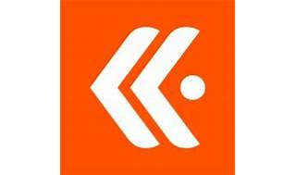



Explore

**Kentik** is the network observability company that provides network flow analytics, monitoring, DDoS detection, and real-time ad-hoc analytics. [It empowers network professionals to understand and optimize their networks, from data centers to the cloud and containers1](https://www.kentik.com/).

Here are **five free reference links** where you can learn more about Kentik:

1. [**Kentik Official Website**](https://www.kentik.com/): Explore Kentik’s platform, system overviews, ingested data types, and query dimensions[1](https://www.kentik.com/).
2. [**Kentik Knowledge Base**](https://kb.kentik.com/): Access detailed information on Kentik’s features, setup, usage, and troubleshooting[2](https://kb.kentik.com/).
3. [**Kentik True Origin for Service Providers**](https://www.kentik.com/get-started/service-provider/): Learn about monitoring the digital supply chain, managing service quality, and optimizing CDNs with Kentik[3](https://www.kentik.com/get-started/service-provider/).
4. [**Kentik v3 Portal KB**](https://kb.kentik.com/v3/Db08.htm): If you’re using the older Kentik portal, this resource covers the v3 version[4](https://kb.kentik.com/v3/Db08.htm).
5. [**Kentik AI and Streaming Telemetry Blog Post**](https://www.kentik.com/): Discover how Kentik reinvents network monitoring using AI and streaming telemetry[1](https://www.kentik.com/).

Feel free to explore these resources to enhance your understanding of network observability and performance with Kentik! 🌐🔍🚀